USER TESTINGS WITH PROTOTYPES
An aggregation of insights and quotes from 38 Prototype Feedback Sessions (13 Veterans who did a one-on-one prototype feedback session; 25 Veterans and VA beneficiaries who recorded self-guided prototype feedback sessions).

GENERAL

General comments
“I don’t think I would have 2 VA Apps on my phone. I think it would be too much”

From an interviewee who uses Claims, CPT coach, breathe to relax, National Veteran legal services program: “All of them feel cartoonish and not really helpful in how they present the interface or how they enable someone to, to work with these. I question whether the delivery and deployment of these as their own standalone apps helps or hurts the VA’s ability to interact with veterans because if anything, it seems that it is fracturing services, where it's like, if you don't know about it, you probably won't ever interact with it.”

“Because the VA literally has to win in their support of veterans and servicemembers, how you present that information truly is something that should be part of a strategy rather than all of these fragmented things that are existing. Again, if you don't know about it, you won't ever find out.”

What do you expect from a VA app? “A super clunky implementation by a lumbering government agency.” (from an interviewee that had not used any VA apps)

Important factors to download an app or recommend an app to others
“Ease of access. Everything should be in one place that I need”
“The fact that the application works”
“I want it to be safe to use, that my personal information wouldn’t be leaked”
--
“Something that I’d need to have on my phone. If it’s something that I would use a lot, I guess. Like in this case, for like notifications you know I would want to know about the appointments or different eligibilities requirements.”
“So if it’s something that I need to have and check a lot”
To introduce to their friends: “Something that’s easy to use and helpful”
--
“I’d say ease of use -- being able to use it. Like I said I didn’t know there was an app or I guess I’m not into apps that’s why I didn’t pay attention to it but now that I see it working it seems a lot more streamlined because I thought it would be more confusing but it seems like it's less confusing and it's more easy to navigate and easy to understand so I would recommend this.”
--
Workable, competent
Would download the app with minimal 1 or 2 functions but would download this app bc it’s all-encompassing. “it seems like everything that you would need to know or need to use through the VA would be here”
--
An app would have to be faster than the website

PROTOTYPE 1 + 2

Method
The uses for this prototype include:
- Determine the value of proposed features qualitatively
- Gather the details for designing and prototyping different features, i.e. answer the questions that we still have given the info from the user interviews
Example: what documents users might download/ upload using the app?
- Pinpoint a set of high-value features to focus on for future prototypes

We intentionally created a really low-fi prototype so that participants could focus more on the insights that we would like to gather.
There will be a home screen with all the proposed features and clicking on one button (representing one feature) will lead the users to the 1st screen of that feature (i.e. features with multiple screens will be represented with only 1 screen).

How they interacted with the prototype: Users were asked to explore the app and think out loud how they might use the app: (1) describe what they think the current screen does, (2) describe what they think will happen if they tap some buttons that seem relevant to them, (3) tap those buttons and speak about what they think and how they feel. There were follow up questions on each of the different screens to gather the info needed to design the feature that a screen represents

Results
We gathered key take-aways from 3 in-depth interviews that we conducted, and put them onto a Mural board. The table shows the text extract from the Mural board being put next to the screenshots of the relevant feature in the prototype. Bolded items are those that we voted to implement in Prototype 2. The items are mostly suggestions from the users. The italicized items are ideas that come from our team.

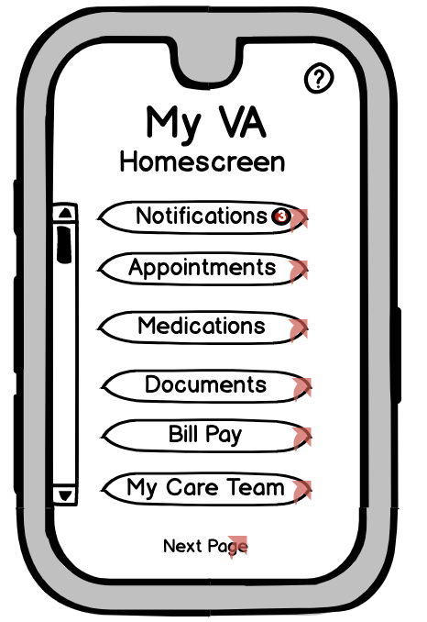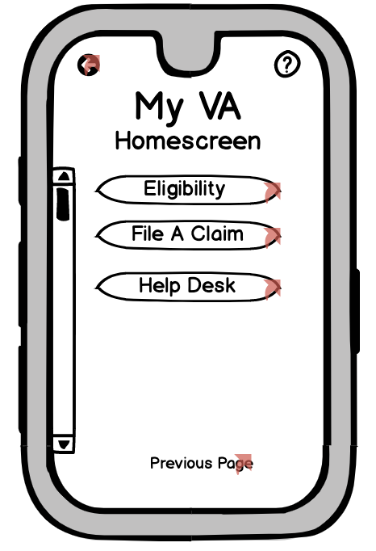  --------------  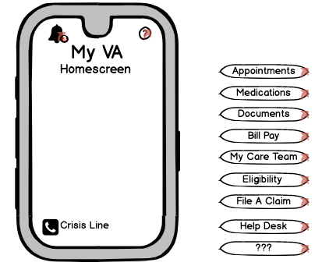 | Home  - Being able to turn on and off features based on mental models of different users  - Frequently used section  - Suicide/mental health hotline  - Being able to customize so most used items on top  - Put all items on one page  - Separating health care from others  - Having option for password instead of fingerprint  - Bundle Appts, Medications, Care team  -------  We changed the home screen into an empty screen so that participants can freely express their ideas.

1: “That the mental model changes depending on what my engagement is with the VA. I think that there's one common engagement with the VA, which is like going for services and or to get medications. [...] So a veteran can be a brand new veteran who has never interacted with the VA. If they are, if it is the first time that they're interacting with the VA, there's a big chance that uh, that they're looking to file a claim or trying to understand their eligibility. So having that a prompt would be helpful. [...] if it's a veteran that already has the determination and or is going through that process. Then having this information higher up and more visible is going to be important. [...] there's another mental model which is you're a family member and try to help someone or you're a
caretaker, try to help someone. But the the last one for me, which cuts across almost all of them are those that are going treatment or care through the VA. And to that I probably would be looking at ‘what are my appointments? What am I medications, who are in my Medicare Team’

1-2: “I'm wondering about the information... if it is important if it shouldn't be presented to me rather than just giving me a bunch of options.”

“Is this only for the VA medical aspect or a holistic VA?”

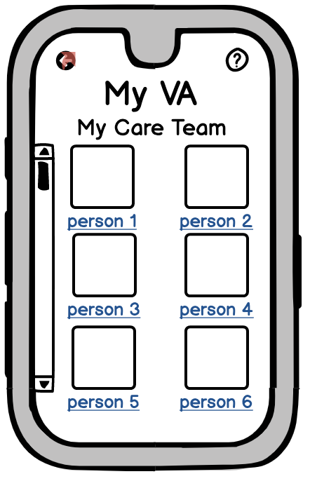 | My Care Team  - Have my care team connect to the appointments page  - Replace in-app messaging with email  - Shows whether doc was veteran or not

3: “at least from my perspective, there's, there seems to not be a lot of veterans in the VA system, or that are working for the VA system. So they can't really relate. That could just be a false narrative that I created by myself. But if I knew that my care team had veterans on them, or at least veterans advocate that were really veterans, I think it would go a long way in trying to bridge that gap between veterans and VA”

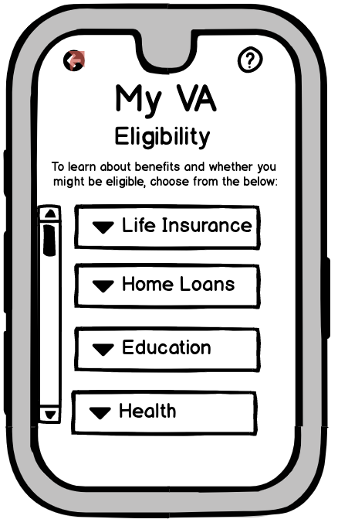 | Eligibility  - Feed info from past applications into new applications  - Include list of documents you need to have available when you talk to someone  - Dashboard for existing benefits (data on $ remaining, etc)  - Send user to appropriate web page  - Checklist of required docs  - Have link to call local VSO for appt

“I think having this here is actually really helpful because you don't know what you don't know. And even as I've gone through, I've looked at just random conversations around what veterans are eligible for and what requirements they have for eligibility. But it's all self discovery. So having that option here is really good. Potentially flagging things that veterans are going to be eligible based on previous information would really be helpful”

1: “When I do my home loan, I have to manually enter every time I've been active duty. Yet that same information is used to compute how much GI Bill eligibility I get for a different VA system.”

“I had very little interaction with the VA. When I got out, I tried to apply for the GI Bill received like two or three months of, of GI bill payments. And then I didn't really push on that one for a VA home loan, a lot more bureaucracy and unsure what was actually happening with that so actually declined not just when the civilian route”

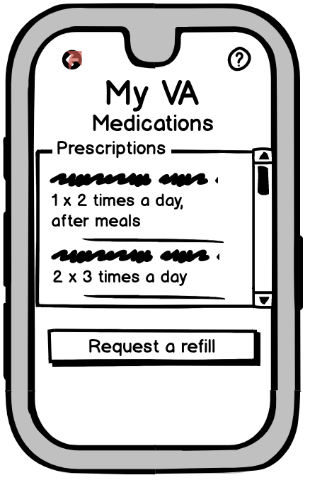  -------------------  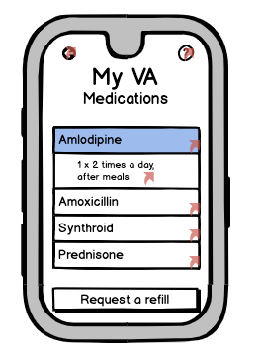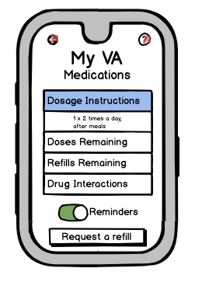 | Med  - Information about drug interactions/FAQ  - Reminder for RX refill DAYS before you run out so it is MAILED in time  - Option to input meds from other docs and OTC meds  - See how many refills and reminder when you need to request another refill  ---------  We add specific details to the feature so that participants could figure out what it is for.

“[Make it] explicitly clear that you know you're on your last refill of this you need to come see the doctor [...] Also pop a notification into that says, hey, you're down to zero random refills, you need to call your doctor or schedule appointment”
“I'm not sure if they're the opportunity for teleconferencing or tele kind of quick appointments are available through the the VA, but something that would be interesting.”

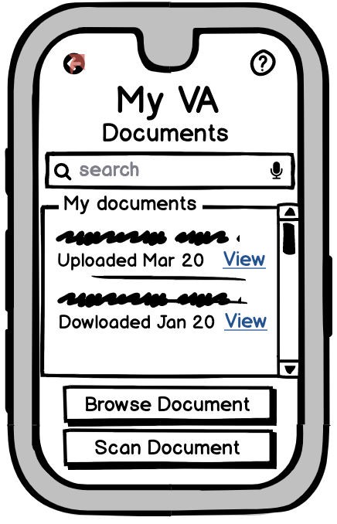 | Docs  - Make an underlying functionality (not distinct)  - Photo upload  - Share  - have tags for docs so that can pull docs out for applications

“I got six pieces of paper because there's something sent twice. One to tell me I owed them money for the tuition. Another to tell me that I owed them money for the housing allowance. And then a third to tell me that I owe them money for the book stipend. And then I got another set of the same three letters with the same two nominations. So notices like that. Not killing a bunch of trees would be great to have in one place”

4: “It’s good to be able to tag something as relevant to you know, an ongoing issue you're having, like health issues. So when you have to resubmit because the VA has denied the claim you don't have to go through a box of papers.”

“And then potentially, I would hope that if the VA uploaded documents they would be able to be seen here. So you'd be able to browse and potentially download documents that the VA uploaded”

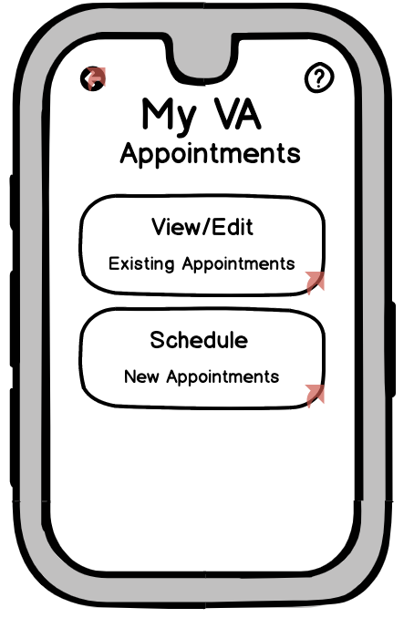 | Appointment  - See list of appointments right away  - Showing existing appointments already scheduled at VA  - Reminder for appts you need to make-- like annual PCP, or colonoscopy  - Suggest appointments  - Instead of new doctor, make it referrals...not sure if VA assigns you specialist...check  - Option to sync with ical, gcal, outlook  - Opens calendar to first available date  - Opens to list of your appointments

“One of my biggest challenges when I used the VA healthcare system in New York, is that when I would get referred out to specialists, everything would have to go through my primary care first, and then to a specialist. So you'd have iterations and appointments to get anything done. So from a convenience point of view, overlaying availability with days I have a future appointments might be something useful so that I can consolidate my trips to the VA and get multiple things done while I'm there will be a healthcare system”

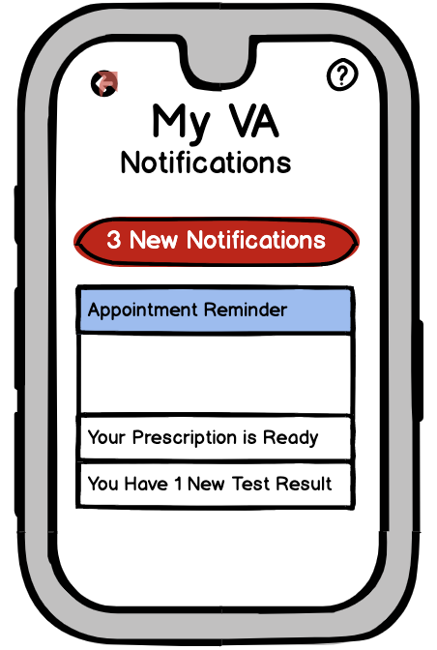 | Notifications  - a global thing rather than a button  - Message center  - suggest relevant VA apps (mental health etc.)  - redirects to relevant screen/ step  - Option to clear notifications, or view past notifications, etc.

3: “It offers you a functionality that is either unique or much better than what currently exists, or we wouldn't need to be tied to something that I'm trying to deal with or that I'm trying to get help with. It can be anything from mental health to financial financial assistance. Because the VA literally has to win in their support of veterans and servicemembers, how you present that information truly is something that should be part of a strategy rather than all of these fragmented things that are existing. Again, if you don't know about it, you won't ever find out. Right? [...] ‘What is going on? Would you like some assistance with financial planning, budgeting, and naturally be able to bubble up other features and functionalities and services’ ”

4: “... treating the notifications as, as a task manager that has a learning component to it. It could be within the different areas. So over here you have like your prescription is ready. Well, chances are that you know how many items were in the prescription that was previously assigned. So you may be able
to say your prescription is ready and then when they tap on it may be a little bit more specific [...] ‘You have five days before you run out of medication’ ‘Can you pick this up?’ Or ‘do you want to switch this to be mailed to you using the vas, like mailing?’ So just bundling up a lot of the functionality that already exists in order to be more helpful. Maybe something to look at”

5: “For me, personally, the appointment notifications would be really important, potentially changes in eligibility as new legislation comes out. Or if there's bill pay, making sure that if there is a bill that I'm getting notified that it's coming due or past due”

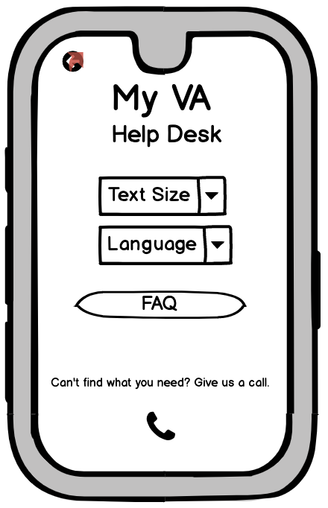 | Help Desk  - Long list of FAQ  - Settings button for size and language  - tells users how to use the app  - Page-specific help screens

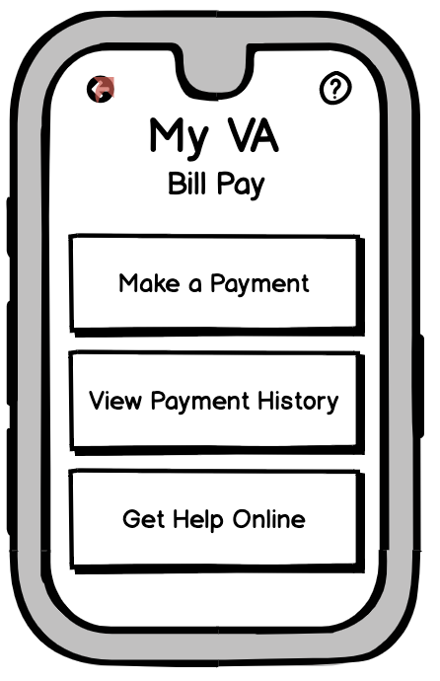 | Bill Pay  - Eliminate from app  - More detailed explanation of bills  - payment security  - Get help if crisis (?) happens

“While I may be a little apprehensive about putting payment card information directly into an app even if it's one from the government. If this were integrated with Apple Pay or Google pay or sale on Samsung Pay Pal then some reputable third party payment processor. I'd be comfortable”

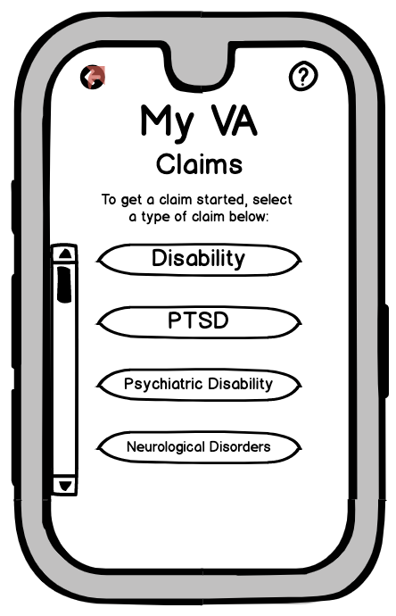  ---------------  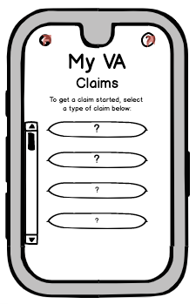 | Claims  - language/ types of claims  - Disability-- mental vs physical?  - Eliminate from app  - Redirect user to appropriate web page  -------  We change the labels so that participants could relate to the types of claims that they’d fill in

1: “it's physical disability and then the other three are mental disabilities”
“Having that kind of in review of those process steps to make sure that someone is actually looking at it. And if someone isn't looking at it or hasn't looked at it for two weeks that you know who to call or, or who to contact, just to make sure that the ball is still rolling.”

Suggestions
- Split out settings
- put the steps together strategically
- 3rd party contacts

Pains
- Too many buttons
- Is this just a health app?
- Does VA beneficiary determination happen before login is created?

PROTOTYPE 3 + 4

Method
The uses for this prototype include:
- Gather people’s reaction to a low-fi design that looks more alike a mobile app
- Get more feedback for the new designs: whether the design is sufficient to accomplish tasks as expected

How they interacted with the prototype: Users were asked to explore the app and think out loud how they might use the app: (1) describe what they think the current screen does, (2) describe what they think will happen if they tap some buttons that seem relevant to them, (3) tap those buttons and speak about what they think and how they feel. There were follow up questions on each of the different screens to gather the info needed to design the feature that a screen represents

Results

General comments
#Impression
“It’s very basic right now like you said it's kind of like a demo but I do like the layout of how it works”
“I think that would be a very helpful quick snapshot of everything going on with the VA”

#Impressed
“As far as what I was expecting and what's being shown, this is one of the best apps I've ever seen because it does have everything there that you would need and it has quick easy functions. Boom boom boom right there that’s good. Again customization is the biggest thing” “This is a very thorough app. It beat my expectation.”
“Very impressed so far”
“I'm not very savvy with apps but I'm actually impressed by what it does right now because it helps me navigate this easily and I don't have to look up and look for help for what it is. It’s very intuitive. I wouldn't change a thing”

#Intuitive
"so you can understand what each section is used for. All Pretty straightforward."
“Trying to navigate between Documents and the Homepage and back again… It doesn’t seem to flow that clearly on the website”
“Totally meets my expectations.”
“It’s very well thought out and self-explanatory - you can just look at it and tell exactly what it does.”
“It's very clear what [the app] can do”
“[The app is] Streamlined, easy to understand and very intuitive to use”

#favorites
“I said it from the beginning when I was thinking app I was thinking that you might have to reach out to pull information in but it looks like it's pulling information to you so that's a good thing”
“Favorite thing is the verteran crisis line, and then the ease of the appointments, the medications, your doctors are there, your healthcare team is there. I really enjoyed the medication section as well because it tells you how many doses are remaining...how may doses should be in the bottle and how many actually are”

#Suggestions
“I think the biggest thing is to have everything customizable as much as you can. The more customization that you have the better because some people like things different; some people like to look at different things; some people like to look at things up front right. Some people just want the nuts and bolts; some people want to hold a lot of information so more than add you might want to subtract…”
Customizable as defined by the participant: what you look at, types of notifications: what you receive and how (email backup, backup for losing or breaking a phone: “An easy and secure way to reboot the app on your phone”).

Being able to update one’s info once across the VA system
Determine how one would receive documents: “That would be huge and like maybe just a checkbox of, like, I want all digital. Boom. Like don't mail me this address that I don't live at anymore because that's like private information you're sending to somebody who lives in a house that I used to own”

Home  - Get rid of quick actions  - Allow people to rearrange homescreen -- my favorites  - Profile button -- address, email, etc. across VA system  - Area to change password  - Include a general profile section with contact info | 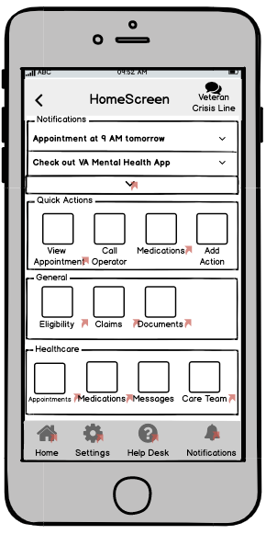

Most common comment: the home screen is “busy” but “intuitive” and “self-explanatory”

1: “I don’t see a need for it because you only have two tabs anyway.”
“It does seem like a lot of things are duplicated...I feel like we’re doubling things here.”

“I like the quick action bar here, it looks useful.” “I guess this is the actions that is popular and people do that people do” “I think it will be good if the person has the option to create what's important to them to it so add onto quick actions down to a general. Maybe have a suggested layout but we can also modify it to what our preferences are. Like something is very important to us, we put it on here and we might take off something that’s not important to us.”

3: “I would like to see more of my information at the top” - name, profile, etc.
“I would like to be able to access my personal VA information.”

“Aligns with healthcare apps that I’ve seen before”
“I’m seeing about everything I’d expect.”
“I think it’s very easy to understand and it would be very useful.”
“I think everything is pretty self-explanatory”

“The things that I would want to do regularly, not that they’re hard to find anyway, I would like to have near the top. That’s a good place for them.”

“So quite a lot of information on this home screen”
[looked at areas on the screen from top to bottom, listed out all the features]
“There’s a lot of information but everything looks really clear and easy to understand”

Notifications  - be able to click on and go to a notification center if not already possible  - function to text, email, push notification, etc.  - edit what they receive and how they receive (content, email) | 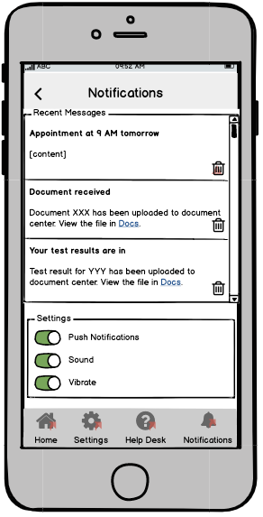

“I really like putting the [notification] settings here.”
“And then a notification is good; it's a reminder.”

Medication  - include doses left in prescription  - include med management options like reminders to take pills, pill tracker, etc.  - in refill, include a pharmacy selection option  - Make click-through to medication details more clear. | 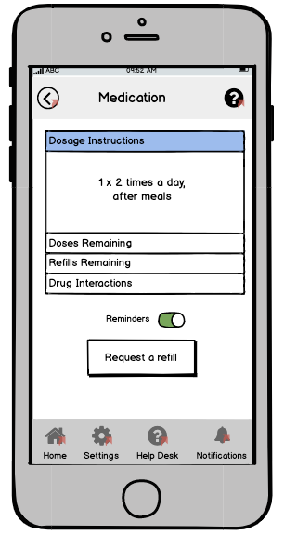

“You can request a refill - that is amazing.”
“This is very nice. I do like that that is on there, because sometimes you forget things...”
“Medication [is one of my favorite features], in case you don’t remember what you need to take. That’s very helpful. You can request a refill.”
“it gives you an understanding of if you have to start monitoring their medications if they are forgetting to take them or overtaking them”

Documents  - name documents for sample  - Make it clear that test results would live here. | 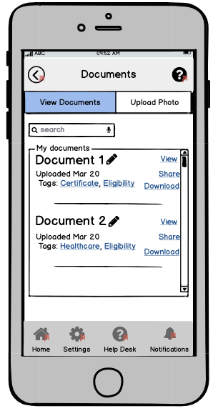
“Oh wow” “I wish I had her documentation saved(?)” (this quote was a little muffled) “that’s really cool”
“Okay so you can upload photos in your Documents. That’s good enough”

An interviewee prefers to have docs offline in the app because the passwords to access to the docs at different sites expire every 30 days. He also worries that this docs might not be taken good care of in the clouds. “And so what happens because of that is people just use really easy to remember versions like keyboard waterfalls [...] so the password is not really secure” (waterfalls = QAZWSX etc.)

Appointment  - some link to 911 or a prompt.."if you are having a medical emergency, please exit the all and call 911"  - change name of appts to be more specific-- people keep getting tripped up  - reminder-- must cancel at least 24 hours before your scheduled appointment (maybe include message with appt reminder)  - include options for when you will receive appt reminder-- 1 week before, 2 days before, 1 day before, 1 hour before, etc. | 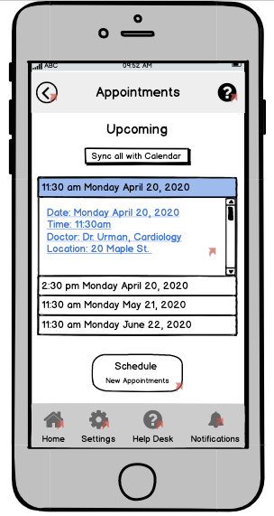
“I really like that I don’t have to click into each one to see the date” on having the suggestion tab and dates circled.
“Straightforward, self-explanatory… It was very easy. I didn’t even have to think about it, it was automatic.”
“I would say that was very easy.”

“It would be nice if other doctors were listed.”
“okay so pretty intuitive so far pretty straightforward easy to you easy to understand”

Eligibility  - add link to eligibility wizard  - reformat the page...still a little unclear what's on there..or ask about directly (Taylor)  - Under my benefits-- when submitted student loan-- received? new prorated amount for housing/book allowance? school loan number there  - Move "My Benefits" outside of eligibility  - status of documents | 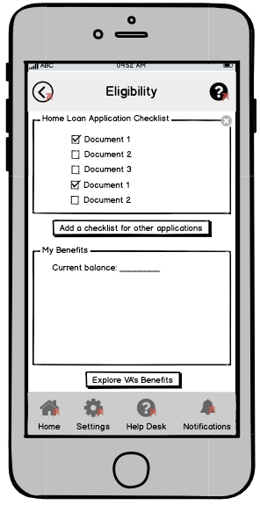
“Okay, that’s helpful - there’s actually more there than I expected. It has all the benefits that you would want to see.”
“I like that it's personalized.”

Expectation for what to see after tapping on “Eligibility” from past experience with the VA and some military app that he used in the past: “A whole bunch of links that will kick me out to a Safari browser on my iPhone and I'll have to parse through them on a tiny little screen and I'll end up going to the VA website. That's what I expect to see”

App vs. Website

“I’m expecting that the website is going to have more information.” (Rate 2/5)
“I would assume that the app is a condensed version, whereas the website has everything that I need to know.”
--
“I think I would use the app before the website.”
“Website has larger layout and more words.”
--
“To be honest, I don’t think I would use the app because… it’s super complicated, so I would want to look on a desktop because it would have more space.”
“Eligibility feels a little bit like the black sheep of the family.” (Meaning it doesn’t fit in with healthcare functions.)
--’
“For eligibility, I would probably use the app - everything’s right there in one place.”
“I probably have more information that I would need stored on my phone than on my computer anyway...and I can do this anytime it comes into my mind, or if I’m on the go, so I would very likely use it. It would probably be my main contact source for Veterans Affairs.”
--
“That actually shows you your eligibility- that’s actually kind of nice, because I know the website is kind of a pain to get to.”
“It’s good to have an app for all this, because just even accessing the website is kind of a pain in the neck, and having it in a simpler app with buttons that are easy to find might be easier for somebody to use. I really like this option, and I think I would be more likely to use this option.”
--
“It’s fairly easy from what I see, but somebody that does not understand technology...it could look confusing for them the way it's laid out. For me, personally, it looks very simple...but some would...be more comfortable looking at a website where everything is laid out”
--
On an app, the screen is a little smaller and on the website of course it’s larger and you’d be able to see all the different forms and if you need to make an attachment or add a file that it might be easier to find it on your computer vs. on the phone you’d have to take a picture of your forms or send in an email or something. But understanding eligibility or benefits, I guess you’d be able to get all the information easily enough on both sites I guess.”
“I guess it’s pretty similar to use both the website and the app but there’s just a larger screen, mainly, when you use the website.”
--
“It’s like quicker actually. On the website you have to click around. This is pretty clear where to go. I kinda like this app a lot because it’s actually kind of more streamlined and the website; the website got so much information on there that you have to kind of browse around vs. with the app it’s very intuitive where to go.”
--
The website for my experience it didn't flow that well [...] it wasn't a clear path to see eligibility, to see documents they have and then try to go back and you had to go to the VA website and then it'll take you to like a Department of Defense website or something like that it would take you outside [...] Everything is here in the app.”

My Care Team  - connect to VA messaging instead of email-- just change the wording  - include care team phone number  - include sample description-- my PCP, are they are veteran, etc.  - maybe rename to contact my care team?  - add link to the schedule appt page  - Make clear it's your doctors (Even just a heading) | 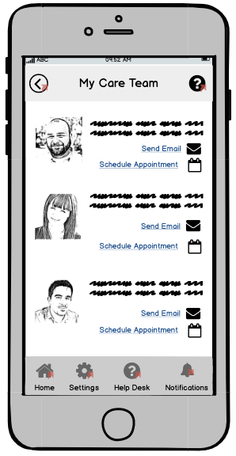

Claims  - Process of starting new claim  - Claim history  - Status of current claim | 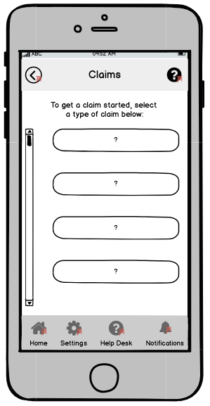

“I would want the app to reassure me that it knows who I am, by telling me that it knows I've already had something going in one of those sections.”

Help desk  “I bank with USAA, and I love their chat function”  The question mark icon hints at page-specific explanation. | 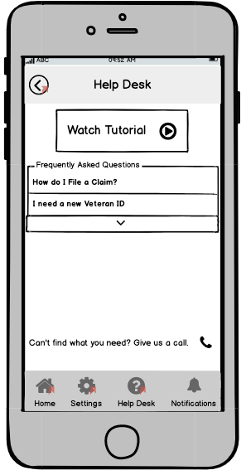

Settings  “I like that that is an option - I know that’s important to a lot of veterans” - on text size. | 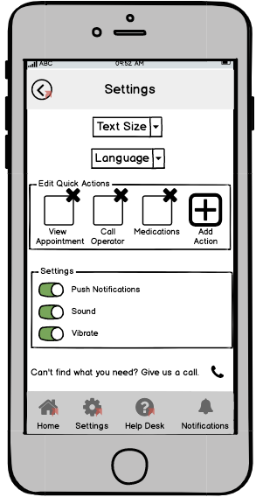

PROTOTYPE 5.0

Changes made to prototype 4.0
Homescreen:
- Altered to be more consistent with ebenefits, but minimal clicks required
- Eligibility screen for Health care, housing, pension, disability, education (insurance and burial tabs for completeness sake?)

Claims Page:
- Deleted claims page (function folded into the individual benefits pages)

Benefits Page:
- Deleted, and separated out into Education, Disability, etc.

Help Desk
- Reformatted to make it more streamlined (in response to comment that it was busy)
- Delete help icon in upper right hand corner (its on the bottom of the screen)

Settings
- Added place to edit My Benefits

Appointments
- Added link to directions for the appointment location
- Added note to care team when scheduling appointment

Medication Checklist
- Added based on user interviews (prior to prototype)

Medications
- Added an add medication (as requested in prototype interview..for OTC meds, etc.)

Education
- Added benefits

Things to Add
- Pharmacy refill page
- Message care team page
- Links
- Healthcare-- link to docs page, or test results
- Request medical records button …

Quotes from interviews

Additional suggestions
“More intuitive functionality of the 'back' button to take you to the previous page you were on, rather than to the previous page of the category you are in.”

“Enable editable banking account information under "My Profile" and allow users to update direct deposit through that icon. Allow users to submit a self taken photo against a white wall in the manner a passport or drivers license photo would be taken to apply for an official VA ID card that would be mailed to their home address. Allow logging in to the app through FaceID or fingerprint scan without having to update the password every 6 months.”

Favorites
“It is customisable. Also, the most important features (Crisis Line and phone directory) are available in one touch from the home page.”

“I like that I am able to see at a quick glance my benefits, apply for additional benefits, upload documents, and be able to get in-app help through the chat feature.”

“I like the interface with customizable icons under the three basic headings "quick actions", "my benefits" and "tools". This design is simple and reflects a typical smartphone home screen design of different icons and apps. The app has everything I can think of that eBenefits or myhealthyvet would offer. Access to all documents, including DD214, old VA letters that might have been mailed out in regard to GI Bill payments, etc. would also be helpful in the "Documents" section.”

“I like how customizable it is and how much detail it goes into about my benefits.”

“I like that it has a lot of good information in one app”

